Linear Regression
Ten participants were surveyed about their levels of perceived stress and the hours of sleep they get each night. The Perceived Stress Score comes from the 10-item Perceived Stress Scale (PSS-10), where higher scores indicate greater perceived stress over the past month (Cohen et al., 1994). Scores range from 0 (low stress) to 40 (high stress).
Research questions:
- Can perceived stress predict sleep duration?
- Does this relationship differ between males and females?

The dataset:
Participant | Gender | Perceived Stress | Hours of Sleep
1 | F | 36 | 4.0
2 | F | 32 | 4.5
3 | F | 28 | 5.2
4 | F | 22 | 6.0
5 | F | 18 | 7.0
6 | M | 36 | 6.5
7 | M | 32 | 6.2
8 | M | 28 | 6.0
9 | M | 22 | 6.1
10 | M | 18 | 6.3

To save you time, a few things have already been calculated for you:
n (overall) = 10
M Perceived Stress = 27.2; sd = 6.88
M Hours of Sleep = 5.78; sd = 0.93

1. Identify the X and Y variables in this dataset.

2. Using the space below, draw a scatter plot depicting the relationship between X and Y. Using a different symbol to note males and females (e.g., small triangles for males and dots for females).

3. How would you describe this relationship based on the plot? Do the patterns differ between males and females?

4. Compute the covariance (cov) between X and Y using the following formula:
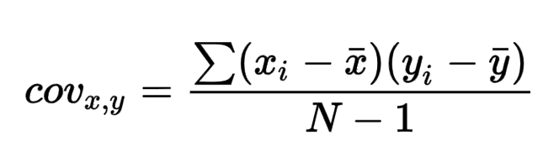

5. Calculate Pearson’s r using the following formula:
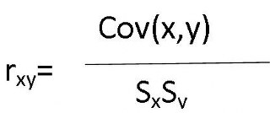

6. Use linear regression to make predictions:
- Figure out the slope (b). Formula: b = cov(X, Y) / var(X)

- Determine the Y intercept. Formula: a = M_{y} – b(M_{x})

- Using the values you calculated in 6a and 6b, how much sleep would you expect an individual who scored a 40 on the perceived stress scale to receive? (hint: use the regression line formula)

7. Figure out how these predictions differ between genders.
To save time, slopes and intercepts for each gender have been calculated for you.
  - Males: b = .0097, a = 5.96
  - Females: b = -.163, a = 9.78

What sleep duration would we expect for males who score a 40 on PS? What about females scoring a 40?

8. Based on these analyses, what conclusions can you draw?

